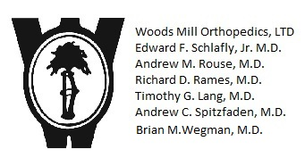
224 South Woods Mill Rd, Suite 330S
Chesterfield, MO 63017
Phone 314-576-7013 Fax 314-576-4047

I, the undersigned, request that an amendment be made to my private health information. The following is a summary of our policy and procedures with respect to amending patient information:
- Requests to amend must be submitted in writing.
- Your request will be reviewed by our Compliance Officer, your physician and other staff members as appropriate.
- If the Compliance Officer and your physician determines the amendment you have requested should be made, the records will be updated as required by federal regulations.
- If our Compliance officer and your physician determines that the information in our records was not created by our practice, not part of your designated record set, would not be available for inspection under 45 CFR 164.524, or is complete and accurate, your request will be denied. A written notice of this decision will be sent to you as required by federal regulations. You will have an opportunity to send us a written statement explaining your disagreement with this decision. That statement will be included in your records, along with any response that we believe is necessary to help future users understand the information.
- We will act on your request for an amendment no later than 30 days after receipt of this request.

Please identify the information that you believe needs to be amended and/or corrected in the space below. Please list the specific information you believe to be incorrect and the reason you believe the information to be incorrect. If no reason is given your request will be denied. If you need additional information please use a separate page of paper.

Last Name, First Name, Middle Initial of Patient: ________________________________________________
Patient Address, City, Zip: ____________________________________________________________________
SSN: _______________ Date of Birth: ______________ Daytime Phone: _____________________________

Signature of Patient or Legal Representative: ____________________________________________________
Printed Name of Patient or Legal Representative: ____________________________Date:_________________

